` `USECASE DIAGRAM FOR ADMINISTRATOR:

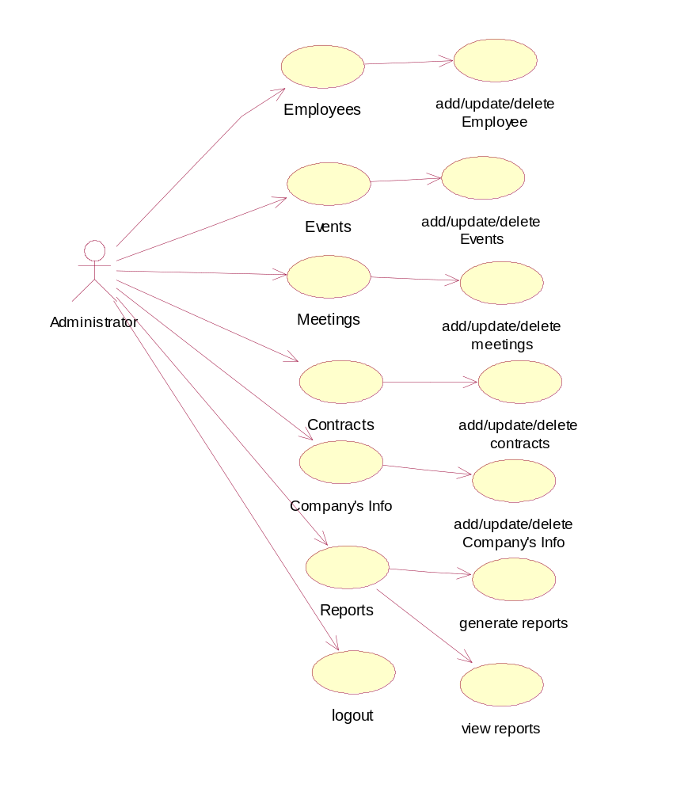

USECASE DIAGRAM FOR EMPLOYEE:

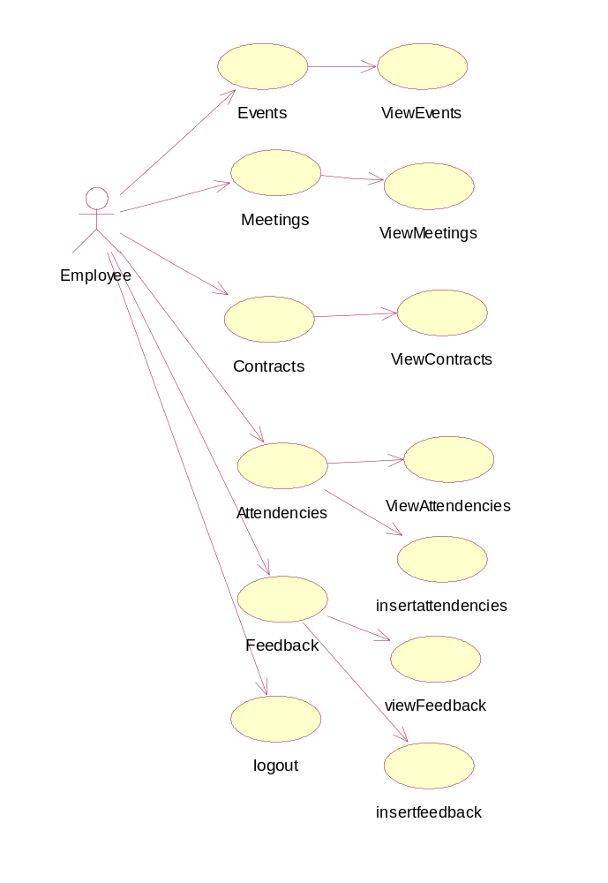
CLASS DIAGRAM:

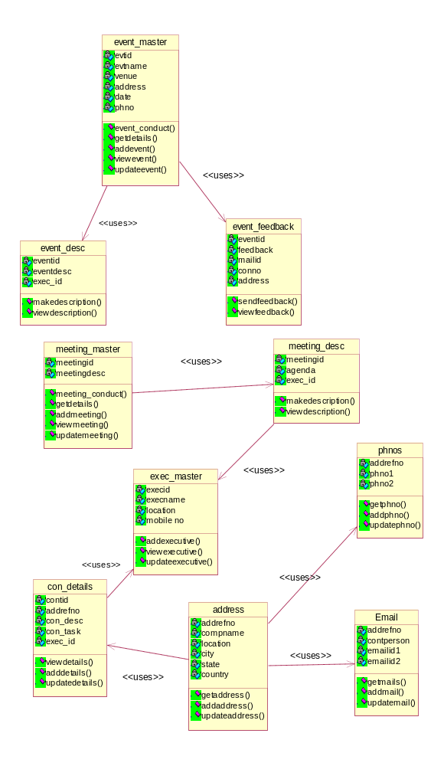

ACTIVITY DIAGRAM FOR ADMINISTRATROR:

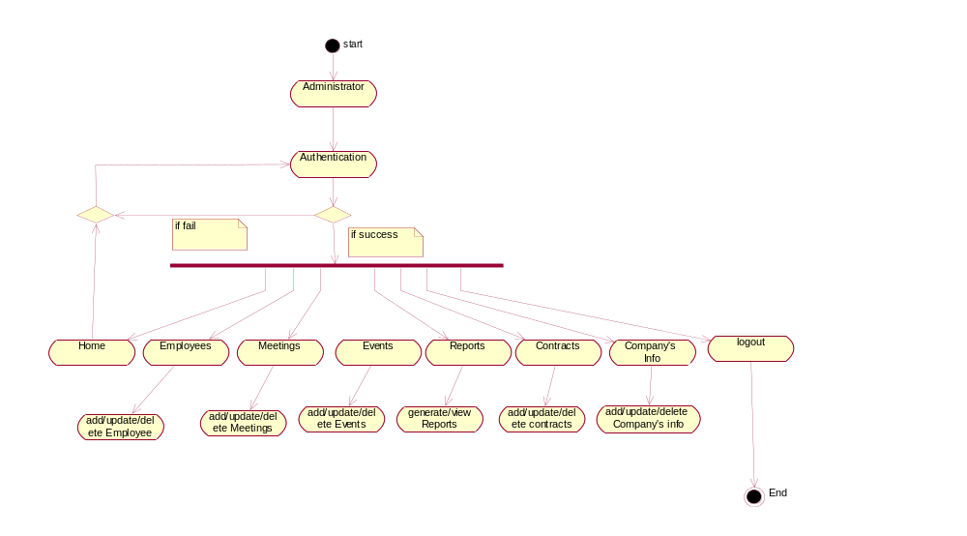
ACTIVITY DIAGRAM FOR EMPLOYEE:

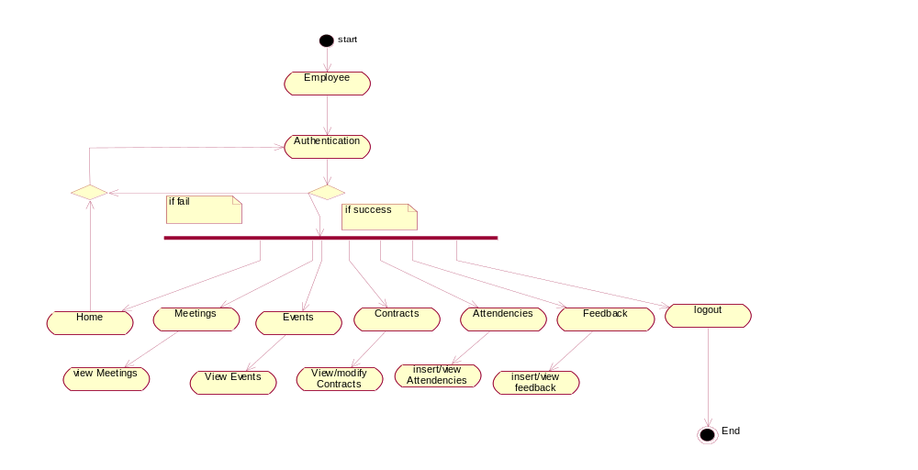

SEQUENCE DIAGRAM FOR ADMINISTRATOR:

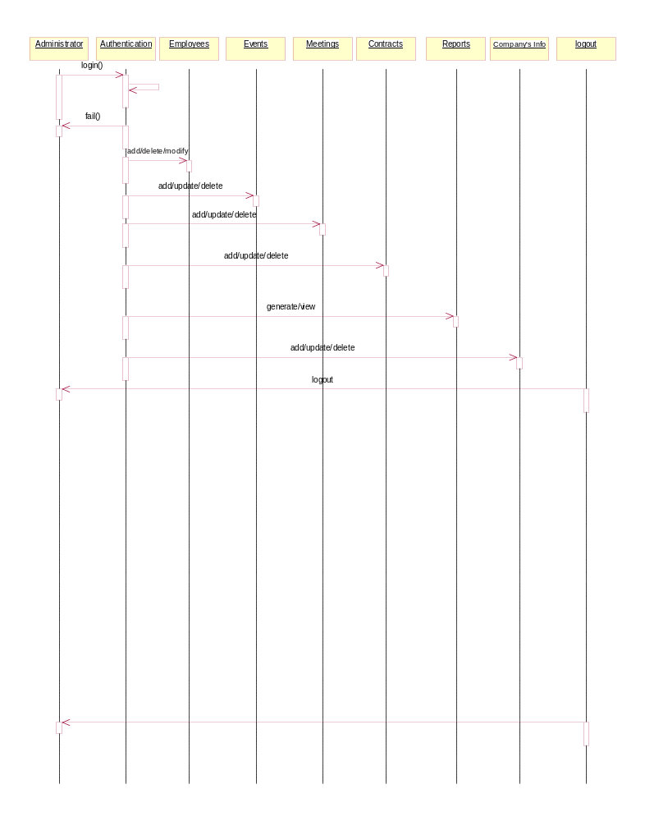

SEQUENCE DIAGRAM FOR EMPLOYEE:

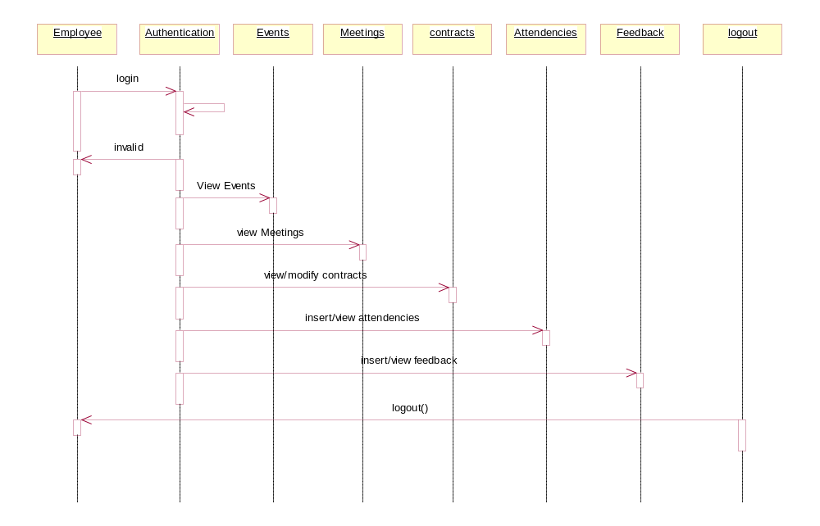

STATECHART DIAGRAM FOR ADMINISTRATOR:

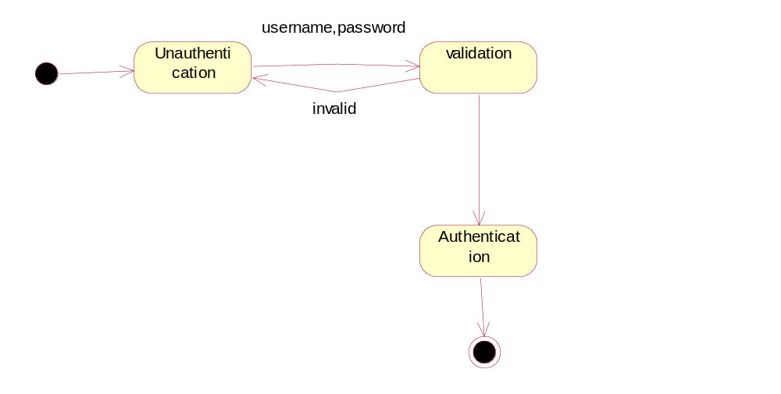

STATECHART DIAGRAM FOR EMPLOYEE:

COLLABORATION DIAGRAM FOR ADMINISTRATOR:

